**All dance styles**

Our team includes dozens of qualified teachers who will teach you such styles as: hip hop, jazz-funk, contemporary dance, break dance, folk dance and much more.

**Jazz-funk**

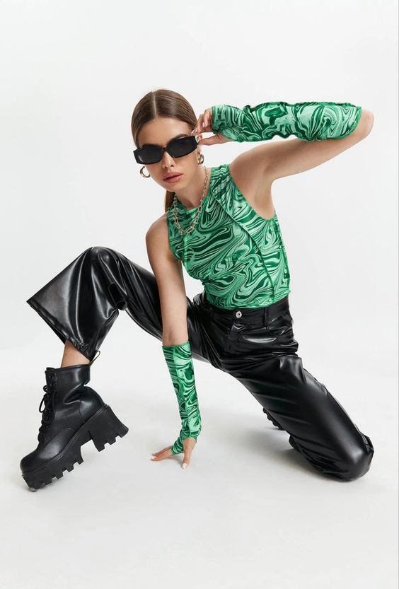

This is Anna and she will show you the world of jazz funk. Dancing this style, you will have unlimited opportunities to express your imagination and your own individuality. In order to start dancing this style, you do not need special training.

**Hip hop**

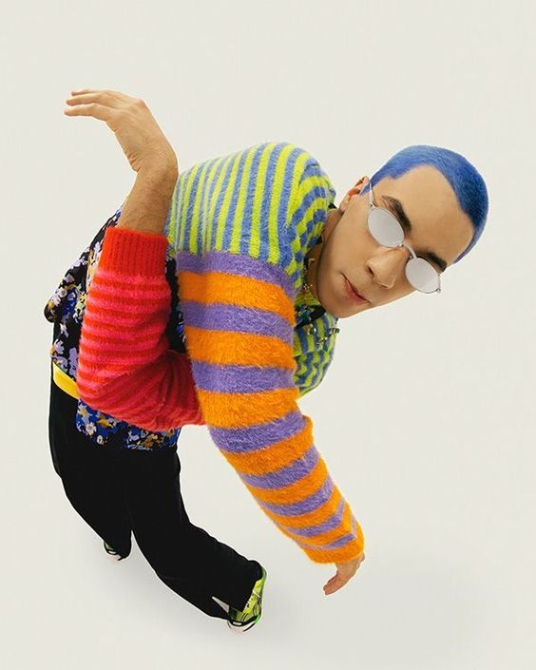

This is Neo and he is already waiting for you in our studio. Hip Hop is a bold, fierce and positive way of self-expression. Hip Hop is the maximum control of your body, the opportunity to learn how to move coolly to the music and attract all the attention of those around you.

**Contemporary dance**

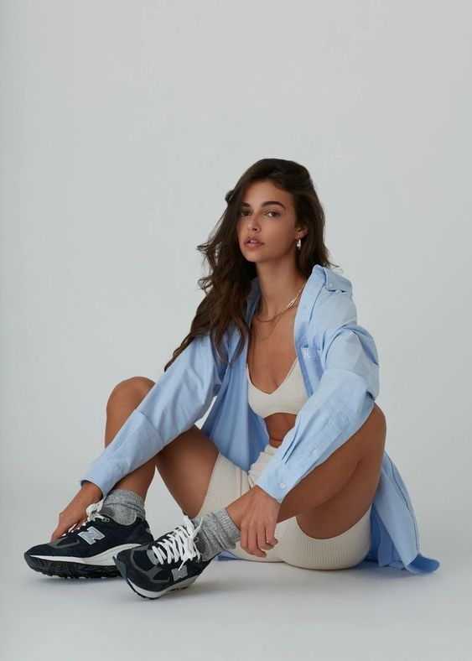

This is Rita and behind her slender back are already thousands of hours spent on the dance floor honing contemporary dance. Contemporary is not just a dance, but a whole art that is designed to teach us to be in harmony with our own body, thoughts and feelings. If you sign up for classes at our dance school, you will be able to learn to express your state of mind with the help of plasticity, falls and rises, work with breathing and calming the nervous system, alternating tense muscles with sharp relaxation.

**High Heels**



This is Lucy and she is waiting for visitors of any class or age in her style of high heels. High Heels is a new, bold dance direction that combines the techniques of such styles as hip-hop, go-go, jazz, jazz-funk and elements from vogue. This energetic, fast dance is performed in high heels.